Governance Part Three
Justice
The Work Part
- Imagine the Haudenosaunee justice were more like ours (emphasis on punishment instead of healing). Now read the story of Tadodaho. How would that story have gone differently? What would have been the fate of the Haudenosaunee Confederacy?
- Using the Wet’suwet’en as an example, explain the concept of “social harmony” and its importance to the functioning of a society.
- Elders take on several roles in First Nations society; often all four being taken on by a single person. Create any three combinations from the four roles discussed in the reading and explain what the benefit of that combo would be. For example, what benefit would there be from having a mediator who is also a teacher?
- Look up the definition for “institution.” Using the reading and the definition you found for guidance, provide three examples of institutions we have and briefly explain how they maintain our social harmony.
- In a paragraph, tell me what you think about the “song duel” method of conflict resolution the Inuit use. Can’t “think of what to write?” Start with your opinion, then pretend I’m standing over your shoulder asking you why you think that.
- Look at the quotation from Art Soloman’s poem in the last section of the reading. Now, using examples from Conflicts With the Canadian Justice System and Restoring Aspects of Aboriginal Justice, discuss how different forms of justice can “multiply evil” or be used to heal and restore social harmony.
Assessment
Criteria / Level | Level 4 | Level 3 | Level 2 | Level 1
Knowledge | Responses are packed with accurate supporting details | Responses contain considerable accurate supporting details | Responses contain some accurate supporting details | Responses contain limited accurate supporting details
Thinking | Nothing is copied. All thoughts are clearly the student’s own and are very insightful | Nothing is copied and insights are pretty clever | I think I see some copying there. Think for yourself! | You’re responses aren’t wrong, but a lot of it isn’t actually you

The Reading Part
“When the white man first seen us, when they first said, ‘Well there’s something wrong with these people here. They don’t have no religion. They have no judicial system. We have to do something for these people.’ I guess that must have been what they thought because they totally screwed up what we already had. We had our own way of teaching our children, like the Elders and everything. There was nothing wrong with that way of teaching children. They just didn’t understand it. The same thing with our judicial system. We had that judicial system and the white people, when they came here, they didn’t see that. They said, ‘These guys have nothing. We have to introduce all these different things to them so they can be one of us.’ That’s exactly the problem we have.
- Chief Philip Michel, Cree
Traditional Forms of Justice
First Nations and Inuit peoples have had their own laws and justice system from time immemorial. Many of these laws are found in sacred stories that have been handed down orally from generation to generation by each community’s Elders. These stories serve as road maps that show people how to lead good lives. They identify the basic values that a Nation of community honours above all others.
The Haudenosaunee, for example, find their code of conduct in the Great Law of Peace. The Great Law honours the values of peace, power and righteousness. The Anishinaabe honour the Seven Grandfather Teachings: wisdom, love, respect, bravery, honesty, humility, and truth. As you have learned, the Inuit also have their own way of encouraging decent, social behaviour. The Metis also developed laws that served their communities long before Canada was created.
First Nations Concepts of Disharmony
In Canadian society today, a crime is generally viewed as an offence that should be punished. The focus is on the individual criminal who is expected to “pay” for his or her crime through some form of punishment: a fine, prison time, or maybe community service.
In First Nations cultures, the focus is not so much on punishment as on healing. The primary concern is to restore balance and harmony to society as a whole. This idea is illustrated in the Haudenosaunee story of Tadodaho, the Onondaga chief who made murderous war on other Nations, as well as his own people:
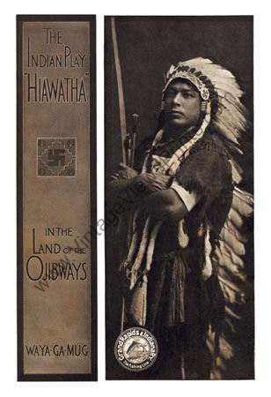
The name Hiawatha might bring to mind the character in Henry Wadsworth Longfellow's famous work of fiction called The Song of Hiawatha, but Hiawatha actually played a very important role in Haudenosaunee history. Born into the Onondaga nation in the early 16th century, Hiawatha was adopted into the Mohawk nation later in life with the aid of the prophet the Peacemaker. Invited to become a Chief among the Mohawk nation, he and the Peacemaker spread a message of peace and founded the Haudenosaunee Confederacy.
Little is known of young Hiawatha’s life until his meeting with the Peacemaker. Living in a time when the five nations of New York State were under constant siege from the neighboring Algonquians, in addition to internal fighting, they lived under constant fear. The most feared warrior was a shaman by the name of Tadodaho, who belonged to the Onondaga nation. It was Tadohado who killed each of Haiwatha’s daughters through witchcraft, sending him into a temporary lapse of grief and self-imposed exile before he eventually ventured into the territory of the Mohawk nation.
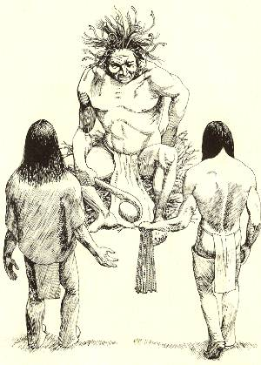
Upon meeting the Peacemaker, Hiawatha was enthralled by his message of peace and unity and joined in his quest of joining the nations of the Haudenosaunee. Meeting with each nation to bring the message of peace, Hiawatha was instrumental in expressing the Peacemaker's message.
Breaking down the barriers of suspicion and hatred over blood feuds among the nations, Hiawatha succeeded in convincing the Cayuga, Mohawk and Oneida to band together. Hiawatha and the Peacemaker faced opposition from the Onondaga chief Tadodaho. It wasn’t until they used a sacred medicine ceremony to cure his mind and body and promised that the Onondaga nation would be the central meeting place and firekeepers that Tadodaho submitted and the Onondaga joined the league. The Seneca had only two opposing chiefs who were won over by appointing them each as war captains for the confederacy.
Restoring Social Harmony
The story about Tadohado raises a question: What systems did First Nations societies have in place for restoring social harmony once it had been disrupted? The answer depends on the Nations and the nature of the offence. One common resolution was the making of restitution to a family that had suffered some kind of wrong.
Restitution is valued by the Wet’suwet’en, a First Nation from coastal British Columbia. In the Wet’suwet’en culture, all the people of a community are thought of as being interconnected within a web of kinship and relations. The highest way of honouring one’s kin (family) is by giving them a feast. A feast is also a way for the perpetrators of a crime to make restitution to the victim of their crime.
A Wet’suwet’en story tells of hunters who accused a group of Nutseni people of poaching on their land. In a raid, the hunters killed several of the trespassers. A blood feud could have followed. Instead, the hunters gave a feast to honour the kin of those they had killed.
The people who gave the feast and presents in this story were following a law of the Wet’suwet’en, a law designed to restore social harmony after an incident of conflict. Only by having such laws and systems of justice can society continue to function.
The Role of Elders
Elders played a critical role in making First Nations, Metis and Inuit justice systems work. They helped pass along the laws from one generation to the next, and they provided guidance in how to apply these laws to specific situations. Today, Elders continue to guide their people in legal matters. We will look at their four main functions.
Elders – both men and women – act as transmitters between the past and present. They are the ones who apply the wisdom of laws to present situations.
In this way, Elders function as teachers of the ethics and rules that form the foundations of Aboriginal justice systems. In Inuit cultures, for example, the Elders usually decide how to divide up the meat after a hunt, and approach that prevents conflict.
Elders also serve as mediators between people in conflict. They listen to everyone involved in a dispute and carefully consider what each person says. Then they make a decision that is based on their teachings and the need to keep the people in harmony with one another.
In some cases, Elders also serve as healers, or medicine men and women. In this respect, they usually take a holistic approach to treating a person who is sick or suffering. Instead of dealing only with the physical symptoms, they consider the “whole package” – a person’s body, mind, and spirit – and the way each of these three aspects of human nature might affect the others.
Taken together, these different roles of transmitter, teacher, mediator and healer all indicate that Elders have an important influence on Aboriginal concepts of justice.
The Role of Institutions
Most Aboriginal communities had their own institutions that were responsible for ensuring that rules and laws were observed. The members of these institutions were Elders. They would meet in designated places where the people would gather to hear them recite the laws or sacred stories or to witness the laws being carried out in specific cases. This could involve the announcement of rulings, or even applying punishments in serious cases.
These institutions included the Clan Houses of the West Coast Nations and the All Brave Dogs Society of the Blackfoot on the Plains. Medicine societies were a specific type of institution responsible for the spiritual well-being of the people. The Midewiwin, or Grand Medicine Society, of the Anishinaabe, is an example of a society that inspired the “upright living” that maintained social balance.
Inuit Methods of Social Control
Like the First Nations, Inuit did not have government officials or police officers to enforce the laws. If an individual broke the accepted code of conduct, Elders would be consulted to see what they recommended. Then the entire community would take responsibility for deciding what sanction should be used.
Cooperation is essential for survival in a cold climate, so Inuit always dealt seriously with any threat to group cohesion. As with the First Nations, the goal was not to punish but to restore social harmony, and to ensure that the group continued to work well together.
To maintain social harmony, Inuit communities would first attempt some form of mild social control. For example, if a person were lazy, someone else might do his or her chores to shame the person into action. If a person were greedy, neighbours might joke about his or her short-comings. If such lighter sanctions failed, the community might try ostracism; that is, everyone would ignore the offender. These techniques worked because membership in the community was valued so highly. Individuals usually responded well and reformed their ways.
For interpersonal conflicts, the matter could be resolved through a competition. Two men might hold a song duel to settle a dispute. They would each compose a song to mock each other. A wife would help sing her husband’s songs, and the audience would decide who was most witty.
For very serious cases, such as physical violence, community members would decide on a course of action together. If a person was particularly difficult of dangerous, the group might move camps without the person’s knowledge – a very harsh punishment in an environment where survival depended on a coordinated group effort.
Conflicts With the Canadian Justice System
When Justice Systems Collide
As more and more European settlers arrived in Canada during the 19th century, many First Nations were pushed off their territories and placed on reserves. Through the treaties and reserve system, through the Indian Act and residential schools, many First Nations lost contact with their lands and cultures. Gradually, the First Nations’ systems of governance were eroded.
Eventually, First Nations’ laws and justice institutions were not as widespread as they had been. Gradually, the government forced First Nations to give up their own justice systems and accept the Euro-Canadian model instead. Under the Indian Act, for example, First Nations and Inuit no longer had the authority to sanction their members for crimes such as murder and assault. Now, this authority rested solely with the Canadian criminal court system.
The shift of authority in the justice systems occurred at different times in different parts of the country. In Western Canada, the process was most decisively marked by the events of 1885. In what is today known as the Northwest Resistance, Metis and some First Nations allies engaged in armed struggle to assert their rights. At the time, these events were known in English as the Northwest Rebellion, but in Cree they were called e-ki-mayakamikahk, or “where it went wrong.” After 1885, a force of 1000 North-West Mounted Police represented the rule of law in Western Canada.
Aboriginal peoples responded in a variety of ways to the imposition of Canadian law on their lives and cultures. One early response was to flee to regions beyond the reach of Canadian law, with the goal of practicing one’s own beliefs and ceremonies in peace. Another response was to contend with the Canadian system. The Metis in particular have focused their efforts on struggling with the Canadian justice system to make it work better for all Canadians.
An Unjust Justice System
There are a few basic difficulties that Aboriginals have had with the Canadian justice system that have been evident from the beginning. Some Aboriginal people experienced a system that was simply difficult to understand because it reflected a different world view. Others faced a system that was corrupted with prejudice at multiple levels.
Virtually all Aboriginal people who had contact with the justice system in the 19th century learned a bitter lesson. Despite the lip service (saying things you don’t back up with actions) that politicians, judges, and lawyers paid to the ideals of fairness and equality, not everyone was considered equal before the law. Over the next 100 years, Aboriginal peoples found abundant evidence that
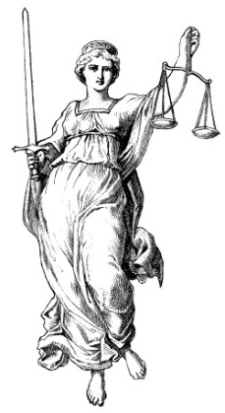
- Aboriginal offenders were more than twice as likely as non-Aboriginal offenders to be placed in jail
- Aboriginal people who were accused were more likely to be denied bail
- Aboriginal people spent more time in pre-trial detention
- Aboriginal people were more likely to be charged with multiple offences
By the late 20th century, the relationship between Aboriginal peoples and the Canadian justice system had reached its lowest point. An Anishinaabe leader spoke frankly in his sworn testimony before a Royal Commission: “There is no justice for Aboriginal peoples in Canada.” When the same Royal Commission issued its report in 1996, the authors summarized the situation in the starkest of terms: “The Canadian criminal justice system has failed the Aboriginal people of Canada – First Nations, Inuit, and Metis people, on-reserve and off, urban and rural – in all territorial and governmental jurisdictions.”
Restoring Aspects of Aboriginal Justice
In 1885, when the Cree chief One Arrow was put in trial for his part in the Northwest Resistance, the court proceedings were all in English. When the court interpreter tried to explain the charges to Chief One Arrow, he translated the word “treason” as “you stole the Queen’s hat and kicked her in the behind.” Chief One Arrow responded, “Is the one who is speaking drunk?”
Things have changed a lot since then. Dedicated people throughout the system are making improvements. For example, Justice Stephen O’Neill – who is not an Aboriginal person – advocates strongly for the application of Aboriginal principles to resolve issues in Ontario courtrooms.
Consider this example of institutional change: A Cree Court was established in northern Saskatchewan in October 2001. Within this court system, the judge, Crown attorney, and legal aid lawyer speak Cree. Witnesses are free to speak either Cree or English, and translation services are available. Because of these innovations, no one involved in the proceedings will have to wonder about strange translations.
The Cree Court tries as much as possible to incorporate aspects of Aboriginal justice. The judge may seek alternatives to prison sentences, such as making restitution to the victim or performing community service. Cases heard before the court usually involve crimes such as the use of controlled drugs.
Sentencing Circles
One of the clearest examples of the revival of Aboriginal forms of justice is the increased use of sentencing circles in Canadian courts. Judges tend to recommend them for crimes such as vandalism or theft, but not for more serious crimes such as murder.
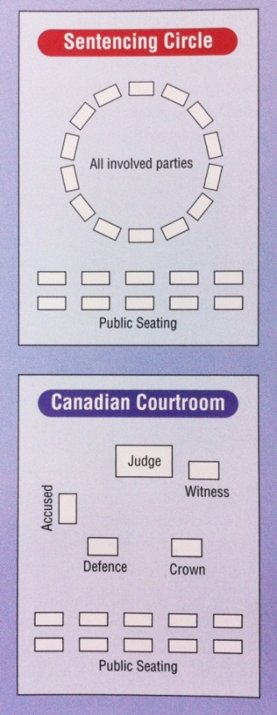
The key idea of a sentencing circle is to concentrate on restoring balance to the community rather than on punishing the offender. The Yukon court system was the first to incorporate sentencing circles in 1992. Since then, their use has spread throughout Western and Northern Canada. Sentencing varies according to the community.
This works by all interesting parties first gathering in a circle. The “offender” takes responsibility for what he or she has done. The community members discuss the matter and attempt to restore balance. Even though the victim does not always participate, the impact of the crime is considered. The typical sentencing circle involves:
- Discussing a plan to correct the offending behaviour
- Appointing someone, often and Elder, to oversee the plan
- Drawing up a schedule to check on the progress
Respecting the Healing Power of the Elders
Anishinaabe Elder Art Solomon once said that the sacred fire of the Anishinaabe almost went out. He and a few other Elders searched through the ashes to find the live embers, which they fanned into flame again. This respected Elder played a major role in rekindling the sacred fire of Anishinaabe spirituality. As a respected teacher, ho provided support to everyone from local community members to learned academics.
Art Solomon was also an activist for First Nations justice, especially in connection with the prison system, which he considered an abomination. He writes in a poem that “the notion that prisons solve the problem of crime is insane, / because it solves nothing. / What it does in fact is multiply the evil.”
Art Solomon led the way to help bring the Elder’s healing power to Aboriginal inmates languishing in prisons across Canada. As one inmate wrote in a tribute, “If it wasn’t for Art Solomon’s letters, poems, and essays which managed their way into my hands and heart, my bitterness would have probably destroyed me completely.”
For more than thirty years, Art Solomon travelled from his French River home to prisons all over Ontario to counsel Aboriginal inmates. At first, he had difficulty gaining access as a chaplain, because the prison system did not recognize First Nations spirituality as a religion. Aboriginal prisoners were not permitted to practice traditions such as the sweetgrass ceremony. Art Solomon went to the World Council of Churches for support, and now Aboriginal inmates have the same freedom of religion as other inmates.

To restore something to its proper owner. In a legal sense, it refers to providing some form of compensation or restoration of status.
A way of enforcing obedience to a set of laws or code of conduct.
The act of excluding.
A thing so horrible / unnatural it borders on evil

