Governance Part One
Forms of Governance
The Work Part
- From the information you find in the reading, tell me what the difference is between each of the following word pairs. That’s different from copying the definition for each. So don’t do that.

government / governance
egalitarian / hierarchical
consensus / majority rules
hunter-gatherer / agriculture
patriarchy / matriarchy
direct democracy / representational democracy
coercion / persuasion

- The reading lists a number of characteristics of a “perfect leader.” Rank those characteristics from most to least important. Write a paragraph explaining your ranking.

- Consider the clan system of the Anishinaabe; could our society use something like that? Instead of animals, come up with about a half-dozen symbols we might use to reflect the characteristics that would help create a harmonious, functional society. For example, a smartphone could represent “connectedness” and the Phone Clan would be responsible for bringing people together in social gatherings.

- Look at the bit I put in italics and underlined in the Inuit section (beneath the picture of the two dollar bill). Why don’t we have that kind of disciplinary system? What was different about the Inuit that made it work for them? What would you rather have: our way or theirs?

- In the Metis section of this reading, you’ll find three sub-sections telling of three different ways in which the Metis developed aspects of their governance systems. For each, discuss why the Metis responded in the particular way they did. It wouldn’t make any sense, for example, to form a provisional government to negotiate a land treaty with a herd of bison. That’s right; this is a question that requires an understanding of “form follows function.”

- Like with the “Laws of the Hunt,” give me an example of a thing we could all benefit from that is often ruined by the actions of one or a few thoughtless individuals. Are there rules in place to try to minimize this behaviour? Do the rules work? Do you have any better ideas?

The Reading Part
Overview
In “Governance Part One,” you will see that First Nations and Inuit had successful systems of government (or a complete lack of government) in place long before the arrival of the British and French. The Metis developed their own unique form of governance, one that combined aspects of First Nations and European systems. Although Aboriginal forms of governance varied somewhat, they all had effective methods for choosing leaders, making collective decisions, and providing for their people.
Learning about historical forms of governance will help you to understand what happened when the federal government, through the Indian Act and other measures, forced Aboriginal peoples to adopt a form of government that was foreign to their culture and unsuited to their circumstances.
First Nations Governance
Government and governance is not the same thing. Government is an official group of people that makes and oversees laws. It alone has the authority to govern its own nation.
Governance, on the other hand, is what governments do: they look after the affairs of a people. Governance means facilitating (setting up the conditions to make possible) the selection of leaders, and hiring employees to follow their direction. It involves managing economic resources, providing social programs, and defending a territory. Governance also entails making the minor, day-to-day decisions that keep a community running smoothly.
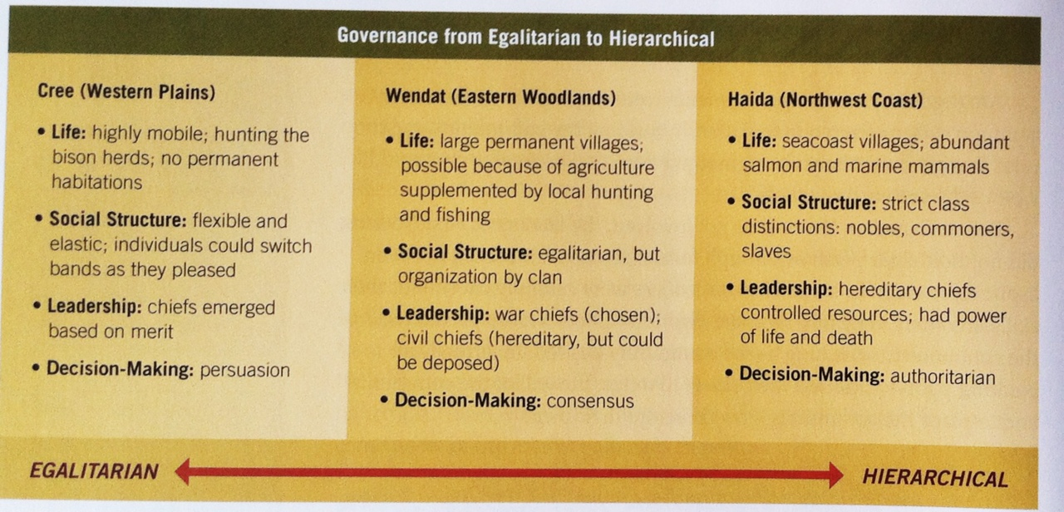
Governance, however, is not just the management of daily affairs. Good governance also means guiding a Nation toward a vision of what the Nation can become. It involves advocating on behalf of the people’s interests, and managing resources to meet the Nation’s goals.
While specific forms of First Nations government varied by region in pre-contact times, most shared at least some of these characteristics:
- They tended to rely on consensus decision-making – people tried to reach common agreement when deciding on a course of action.
- They depended on the active participation of individuals – everyone had the right to share their opinion and skills.
- Most did not rely on coercion – instead, they employed persuasion.
- They respected diversity – leaders sought opinions from many people and tolerated many types of behaviour.
- Many were flexible – people followed particular leaders at various times depending on the leader’s effectiveness and area of expertise.
- Many were egalitarian – there was little difference in status between leaders and other people.

Among First Nations, governments were not seen as distinct from common society. Everyone took part in running the community, and the rules that governed behaviour emerged from the spirituality and world view of the society as a whole.
Before Canadian lawmakers got involved, the leaders of First Nations did not hold their position through formal elections. Most did not even aspire to be chief. In some Nations, leaders were carefully chosen for their skills. In others, they inherited the position. Chiefs were expected to serve the community for as long as the community desired. In virtually all Nations, people expected their chiefs to reflect the will of the community and to place the community’s needs before their own.
Despite many common characteristics, First Nations governments also varied quite a bit. These distinct forms reflected variations in geography, population size, culture, history, and relations with neighbours. Smaller Nations that followed the movement of animals tended to need a different form of government that did larger and more settled Nations. In the diagram above, you can see the range of different forms of government from more egalitarian to more hierarchical.
Most original forms of Aboriginal government were overturned by the passage of the Indian Act in 1867. This act forced all First Nations to have an elected council and chief. Many Nations preferred a system whereby chiefs held power at the discretion of clan mothers. When the federal government forced the election of chiefs (who were usually men), it disempowered women.
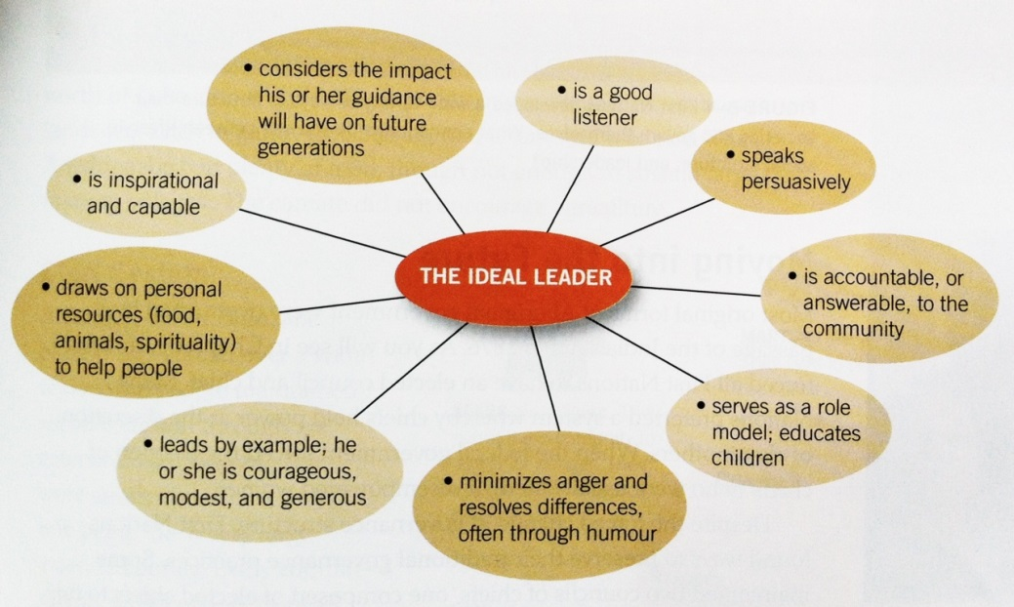
Despite the forced change in governance structure, First Nations found ways to preserve their traditional governance practices. Some maintained two council chiefs, one composed of elected chiefs to fulfill the role required by the federal government, and the other composed of hereditary chiefs to provide guidance and stability to the Nation. Some Nations preserved their practices, such as the potlatch, in secret. Some Nations simply blended the old with the new, imbuing the new form of government with Aboriginal values.
It is a credit to the resilience of First Nations governments that they have persevered through difficult times. Many Nations are working toward, or have already achieved, self-government, a way for First Nations to regain some of the governance powers they previously lost.
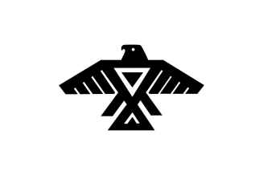
In time immemorial, the Anishinaabe people followed a prophecy, travelling from their East Coast homeland to the region now known as Ontario. Over time, they divided into different Nations, three of which joined together in a powerful alliance called the Council of Three Fires. According to Potawatomi Elder Shup-Shewana, the council dates back to the year 796 CE. The Ojibwe are the faith keepers; the Odawa are the Traders; and the Potawatomi are the Keepers of the Fire.
Wikwemikong is the preferred home of the council, on Manitoulin Island, the largest freshwater island in the world. The location serves as the Council’s political and military meeting place. It is also one of only two officially recognized un-ceded Indian reserves, meaning that the Anishinaabe never gave up title to the land.
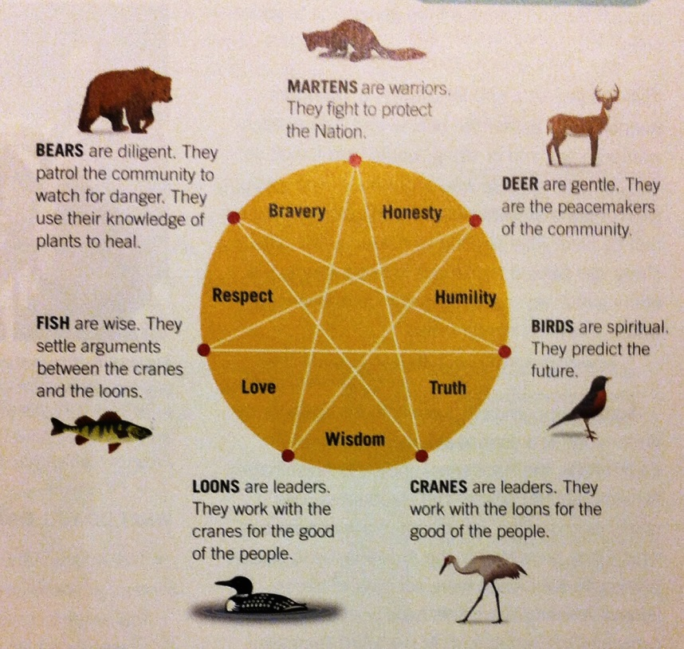
The ancestral lands of the Anishinaabe peoples stretched from the north shore of Lake Ontario northwest around Georgian Bay to the lands north of Lake Huron and Lake Superior. In pre-contact times, these lands were rich in game, fish, berries, maple sap and wild rice. The Anishinaabe had plenty of food, though not enough to sustain large, permanent villages as you would if practicing large-scale agriculture.
Although the Anishinaabe Nation was spread over a wide region, the people maintained social cohesion through an extensive clan system. There were seven main clans, each one being like a very large extended family. Every community included people from all seven original clans.
Each clan had a totem – an animal symbol. Each totem represented particular qualities that the people of that clan were said to embody. Martens, for example, made good warriors, while cranes and loons made good leaders. This system gave every person a way to contribute to the successful governance of the community.
Today, Anishinaabe continue to employ consensus decision-making in their governance structures. Respectful listening and leading by example are a just a few of the values that Anishinaabe have retained.
In 1949, the Anishinaabe established the Union of Ontario Indians as their political advocate. It currently represents 55 000 people. With roots in pre-contact times, it is the oldest political organization in Ontario.
Inuit Governance
Before the 1940s, most Inuit lived in small groups that moved in seasonal cycles over the Arctic lands in search of food. They had no formal government, though they did have well-defined processes for governance. Their society was generally peaceful. However, about seventy years ago, the federal government started forcing the people to live in permanent settlements, a change that has brought great stress to Inuit communities. As you will see, Inuit have turned out to be highly resilient, retaining their identity and optimism as they work to build a new Inuit future.
In historical Inuit society, people generally lived in small groups of related families. They would move from one area to another as the seasons changed to take advantage of the seasonal availability of natural resources. Inuit lived off the land, hunting caribou, sea mammals and small game. They also fished and collected birds’ eggs and berries to eat. Occasionally, families would come together in larger groupings. For the most part though, each family group had to be totally independent and self-sustaining.
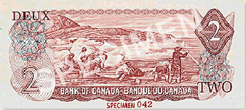
Inuit did not have laws that were written down; rather, they had rules or social customs that were handed down orally from generation to generation. Every person knew and understood these rules and was expected to follow them.
Various Inuit values and social traditions helped to keep conflict to a minimum. For example, Inuit, like most Aboriginal peoples, did not interfere in the lives of others and valued self-reliance. Mutual respect was expected and given. They also valued sharing and hospitality, and refrained from making direct requests of others. As well, Inuit considered the expression of anger or impatience socially unacceptable and childish. Because Inuit embraced these behaviours, their communities were able to run smoothly without formal government structure.
Before the Canadian government got involved in the Arctic, Inuit did not have police officers to enforce the customary laws. Instead, they relied on spiritual beliefs, principles, and taboos to enforce acceptable behaviour. The Inuit realized that social pressure exerted by the entire community could be extremely persuasive.
Inuit did not put in place official or formal authority figured to lead them. Good hunters would share their advice and expertise, but everyone was at liberty to go their own way. Certain activities, like whale hunting, might require a specific leader who would give instructions on what to do and when, but once the activity was over, so was that person’s authority. Elders held great importance because of their experience and knowledge, but again, if people sis not like their counsel they could ignore it and do what they thought was best.
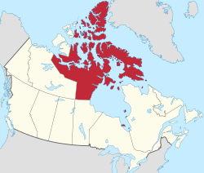
Because Inuit lived in such small groups, often for long periods of time, conflicts often arose. That is why leaders who could help restore and maintain social harmony within the community were highly valued.
The same can be said today: members of the Nunavut Legislative Assembly are expected to work together for the good of Nunavut, with consensus as their goal. Inuit of Nunavut have a public government that creates laws and administers programs for the whole territory of Nunavut. The sheer size of the government stands in sharp contrast to historical forms of Inuit governance. Yet it is a credit to Inuit that they have been able to infuse their legislature and programs with Inuit values.
At a different level, Inuit have a different type of organization working to protect their interests: the Inuit Tapiriit Kanatami, which represents the interests of tens of thousands of Inuit throughout Canada. This is not a lawmaking or administrative organization. Instead, it steps in when there is a need to protect the community.
Metis Governance
After their emergence as a people, the Metis gradually moved toward a sense of nationhood. As the metis have drawn from cultures of their First Nations, French, Irish, and Scottish ancestors to forge their own culture, so have they drawn on these sources as they developed their laws and governance structures.
Throughout the Metis homeland, the Metis found ways to govern themselves that reflected aspects of their world view. These included their close relationship with the land on which they lived, their respect for democratic practices, and their understanding of the basic need every community has for stability and security.
A sense of nationhood and a desire for self-governance tend to go hand in hand. For a Nation to survive, it must protect its interests. For example…
The Battle of Seven Oaks
The Metis sense of nationhood grew in the early 19th century, as the Metis asserted their rights in Rupert’s Land – the vast Hudson’s Bay Company territory. They found an ally in HBC’s fiercest competitor, the North West Company, which did not recognize the HBC monopoly. In several encounters, the Metis challenged HBC authority over their lands.
The most dramatic of these early encounters took place at Seven Oaks in 1816. The North West Company appointed Metis Cuthbert Grant as Captain-General of the Metis. With volunteers, he began raiding HBC posts on the Assiniboine River. Confronted by HBC governor Robert Semple and 28 armed men, Grant offered to talk. When HBC men responded with gunfire, the Metis fired back, killing Semple and 20 others, while one Metis died.
The battle of Seven Oaks, celebrated in verse by the Metis poet Pierre Falcon, is regarded by many as the very birth of the Metis Nation.
Striving for Fair and Representative Government
The Metis first formed a government in Red River in 1869. When Canada bough Rupert’s Land from the HBC, the 24-year-old Louis Riel realized that the Canadian government might not recognize Metis land rights. He responded by getting politically organized.
First, Riel called on the parishes in the region to elect representatives to a council that would respond to the Canadian government’s planned land transfer. To avoid charges of favouritism, he asked for twelve French-speaking and twelve English-speaking representatives who would form the Comite national des Metis.
When violence broke out, the committee declared itself a provisional, or temporary, government. Louis Riel drafted a list of rights to serve as a basis for negotiations with the Government of Canada. By the time negotiations were complete, the federal government had signed the Manitoba Act. This law created the first Canadian province to protect the rights of a minority: it guaranteed French language rights, the right to a Roman Catholic education, and Metis land rights.
Laws of the Hunt
An example of Metis administration of local affairs stems from the bison hunt. So many people were involved – and so much could go wrong – that the Metis demanded complete cooperation and coordination from everyone. If even one participant got out of line and fired a rifle at the wrong time, the herd might stampede and the hunt might be ruined for everyone.
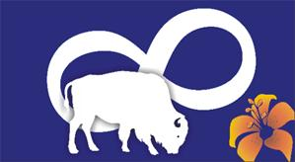
Borrowing from their French and British heritage, the Metis developed a hierarchical command structure. On the first day of a hunt, the people elected a president and ten captains of the hunt. Each captain then selected ten soldiers to assist with discipline and order. Their job was to see that the Laws of the Hunt were observed.
The command assignments lasted only as long as the hunt itself. However, the command structure and the Laws of the Hunt show ways of thinking about organization that Metis continue to use to organize themselves today.
Laws of the Hunt
- No buffalo to be run on the Sabbath Day (Sunday)
- No party is to fork off or lag of go before (to hunt bison) without permission
- No person or party to run buffalo before the general order
- Every captain, with his men, in turn to patrol camp and keep guard
- For the first trespass against these laws, the offender is to have his saddle and bridle cut
- For the second offence, his coat is to be taken off his back and cut up
- For the third offence, the offender is to be flogged (whipped)
- Any person convicted of theft, even to value of a sinew, to be brought to the middle of the camp, and the crier is to call out his or her name three times, adding the word “thief” each time

Super Power-Up Mega Bonus Almost Guaranteed a 4+ if You Do This (optional)
Now that you’ve done some reading (and hopefully thinking) about the various ways we try to get everyone getting along; write me a paragraph or three or seven discussing the role trust plays in society. To put it another way, is there something about our large-scale, industrial society that makes impossible to have a loose, informal form of governance like, say, the Inuit or Blackfoot?

A subdivision of a country served by a church, not unlike “township” or even “province.” It also came to mean a political subdivision of a country. The Metis used this term when subdividing their settlements.

