Governance Part Two
The Indian Act
The Work Part
Time Scroll
For this part of the Governance Unit, you will create a Time Scroll that places in chronological order, all the many things that have happened over the past 150 years of so that are related to the Indian Act.
Steps:
- Read through the handout and make note (write a super-brief summary of the item) of anything that has a date, period of time or year attached to it
- Now put those items in order
- Now get a “scroll” from Mr. King and place your items, in order, along a timeline
- Use a colour-coded system (provide a legend) to indicate which developments were good for Aboriginal people and which were bad (add a third colour for neutral if you think it’s necessary)

No, you don’t have to do this on a scroll. Other media are fine, as long as the information is still there.
Assessment
Criteria / Level | Level 4 | Level 3 | Level 2 | Level 1
Communication | Scroll is neat, clear and very easy to understand | Scroll is considerably neat, clear and easy to understand | Scroll is somewhat neat, clear and easy to understand | Scroll is a bit of a mess, but I can still make out the information
Knowledge | Scroll is packed with virtually every detail possible | Scroll contains most of the relevant information | Scroll contains some of the relevant information | Scroll contains a bit of the relevant information
Thinking | The colour coding is thoughtful and makes perfect sense | The colour coding makes sense | The colour coding makes some sense. I guess. | I suspect you may have just been grabbing random crayons out of the box

The Reading Part
“The Indian Act was one of the first major steps taken by the government of Canada to weaken the treaties signed with our people, for now it is from the Indian Act that the legal position of the Indian primarily stems, rather than from the treaties themselves. This piece of legislation that was supposed to implement the terms of the treaties was surely written by people who understand or cared very little about protecting human rights but who were thoroughly concerned and familiar with concepts and laws characterised by colonial powers.”
- Harold Cardinal, from The Tragedy of Canada’s Indians

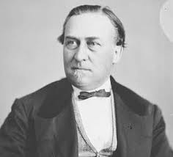
During the debate before passage of the Indian Act in 1876, Sir Hector Langevin, a Member of Parliament and a Father of Confederation, rose in the House of Commons and stated that “Indians were not in the same position as white men. As a rule, they had no education, and they were like children to a very great extent. They, therefore, required a great deal more protection than white men.”
Sir Hector Langevin’s statement reflected a paternalistic (father-like) attitude common among Canadian politicians of the time: that First Nations people were not just different, but also inferior. They could not think for themselves, and therefore had to be protected from unscrupulous people who would otherwise steal their lands. According to this line of reasoning, the need for protection meant that First Nations people had few legal rights in Canada.
Passage of the Indian Act in 1876 made most First Nations people in Canada “wards of the state.” In other words, they had the legal status of children who required protection and supervision. As a result of this legislation, First Nations people had to obey a federal law that controlled virtually all aspects of their lives. The Indian Act also had the stated purpose of gradually assimilating First Nations into Canadian society, a process meant to erase their distinct identity as Aboriginal peoples.
Earlier Legislation
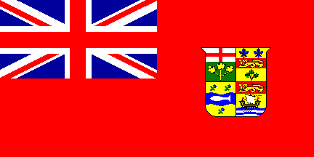
Under the British North America Act (BNA) of 1867, Canada’s Parliament was given exclusive power to deal with “Indians and Lands reserved for Indians.” By the time Parliament passed the Indian Act nine years later, several laws that applied to First Nations and their reserves were already in effect. One of the intentions of the Indian Act was to consolidate these different laws into one package.
Three of these earlier laws were particularly important because together they defined what had become the federal government’s policy in regard to First Nations. This policy had the following goals:
- Protection of reserve lands
- Civilization of First Nations peoples
- Assimilation of all First Nations into mainstream Canadian society

A brief look at each of these laws will illustrate what the government wanted to accomplish with the Indian Act and why First Nations have, over the years, accepted some of the Act’s provisions while actively resisting many others.
Acts to Protect Indian Lands (1850)
In 1850, the provinces of Upper and Lower Canada passed separate but similar acts to protect First Nations lands and the resources on them. At this time, many First Nations were having problems with squatters living on reserve lands and with outsiders harvesting timber illegally. The 1850 laws made it a criminal offence to trespass on reserve lands and for anyone other than the Crown (the British Government) to purchase these lands. The laws also exempted reserve lands from taxes and seizure for debt payments.
While First Nations, for the most part, welcomed these legal protections, the laws also had far-reaching effects in the identities of First Nations people. For the first time in Canadian history, the government set out a definition of who could and could not be considered an “Indian.”
The 1850 Acts defined “Indian” as anyone who had Indian blood or was married to a person of Indian blood. By the time the Indian Act was passed in 1876, this definition had been amended to exclude non-Indian men who married Indian women.
Many First Nations resisted the very idea that the federal government should claim the right to decide who could or could not be an “Indian,” rather that acknowledging that First Nations has the inalienable right to make such decisions themselves.
The Gradual Civilization Act (1857)
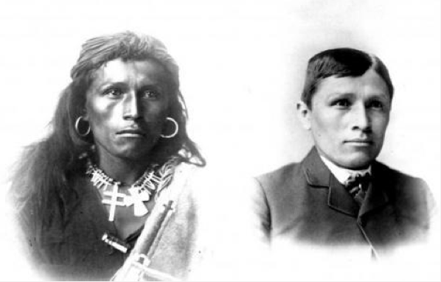
The Dominion government (Canadian government while were still a colony of Britain) announced its intention to “civilize” First Nations in Canada by passing the Gradual Civilization Act in 1857. The government’s view was that the best way to civilize First Nations was through voluntary enfranchisement, the process by which a First Nations man (only males could apply) would give up his Indian status to acquire the full rights of Canadian citizenship, including the right to vote.
The Gradual Civilization Act laid out both the requirements and rewards for enfranchisement. The candidate had to be an educated male, at least 21 years old, with the ability to read, write and speak either French or English. He had to be debt-free and of a “good moral character” as determined by a review board that consisted entirely of non-Indian members.
If he were enfranchised, the candidate would receive up to 50 acres (about 20 football fields) of reserve land for his own use. He would not own the land outright, however. On his death, the land would either revert to the Crown or be handed down to his heirs, who could then dispose of it as they pleased. Either way, the reserve would lose a parcel of its treaty lands without any say in the matter.
Most First Nations were infuriated by the passage of this Act and some petitioned for its repeal. They considered the Act to be a double-barrelled attack on their nationhood, first by inviting members to renounce (give up) their Indian status and second by chipping away at the reserve land base.
The Gradual Enfranchisement Act (1869)
In 1869, two years after Confederation, the Canadian Parliament passed the Gradual Enfranchisement Act to further encourage Indian assimilation. Government officials believed that the First Nations tribal councils were actively discouraging their people from being enfranchised, so the government decided to seize control of the councils. In effect, this denied First Nations the right to self-government.
Through this Act, government officials could force First Nations bands to adopt elected councils. Chiefs and councillors would be elected for a three year term. Only men could vote in the elections. This followed Canadian practice but was in direct conflict with First Nations traditions in which women played a prominent role in choosing the community’s leaders.
This model of an elected council was based on the municipal government system in mainstream communities but ignored traditional forms of governance in which chief and councillor were often hereditary (inherited) positions. The elected councils could make by-laws for such matters as road maintenance and school construction, but every by-law had to be approved by government officials.
The Gradual Enfranchisement Act was also the first law in Canada to make the distinction between “status” and “non-status” Indians. The distinction was important because only status Indians had the right to live on reserves and receive government assistance and because, for the first time, the Act formally denied status to any Indian woman who married a non-Indian man.
By incorporating the three earlier laws into the Indian Act, the Canadian government set in motion forces that would not only weaken the terms of the treaties, but also subject First Nations to many of the oppressive aspects of colonial rule.
Metis and Inuit Under the Indian Act
One thing that should be noted about the Indian Act is that, even though it has been around for more than 130 years and has been amended (altered / added to) dozens of times, the name has never changed. It has always been called the Indian Act, never the “Aboriginal Peoples Act.” The name has remained the same because the rights and benefits that the Indian Act grants to status Indians – such as on-reserve housing and certain tax exemptions – are not extended to the other two Aboriginal peoples in Canada; the Metis and Inuit. In fact, the rights and benefits are not even extended to all First Nations people, but only to those who meet the Act’s narrow definition of “status Indian.” For the most part, this means people who are members of a recognized Indian band that is centered on a reserve.
Over the history of the Act, the government took steps to deliberately exclude Metis and Inuit from coverage, partly because it did not want to pay them the same benefits as status Indians. Despite this exclusion, there were limited times and circumstances when Metis and Inuit qualified as “Indians,” and so came under the coverage of the Act.

The Metis
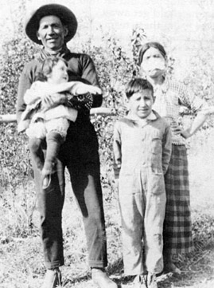
Under the 1876 Indian Act, Metis who wanted to live on a First Nations reserve – and were accepted by the community – could identify themselves as “Indians.” Their names were then entered onto a document called the band list, and they were allowed to occupy reserve land. The only exception to this rule were Metis in Manitoba (and later from any western province) who had taken government scrip, a certificate that entitled them to land or money.
The problem was that, although Metis could qualify for reserve lands and other benefits by identifying as Indians, they could not do so as Metis. Prime Minister John A. MacDonald summarized the government’s position in 1885 by saying, “If they are half-breeds, they are, in the government’s eyes, white.” The government refused any Metis demands for rights as a distinct people by suggesting that, if such rights existed, they were a provincial responsibility. In effect, this meant Metis had to deny their own heritage and call themselves Indians to receive government benefits under the Indian Act.
In 1985, Bill C-31 amended the Act to restore status to Indian women who had married non-Indian men, and to the children of these marriages. Over the next several years, more than 100,000 people – some of whom had been identifying as Metis – were added to the Indian Register and received status cards.
Today, Metis are still not recognized under the Indian Act unless they first obtain status as registered Indians. However, since the Metis acquired formal recognition as one of the Aboriginal peoples of Canada in the Constitution Act of 1982, the federal government has admitted some limited obligations toward them.
In practical terms, this means the Minister of Indian Affairs also functions as the Federal Interlocutor for Metis and non-status Indians. The Federal Interlocutor is the government’s “contact person” who advises the Metis organizations about federal policies and programs that have some bearing on the Metis people. He or she also participates in any tripartite (three-way) negotiations between Metis and the federal or provincial governments.
Inuit
Inuit have had a strange relationship with the Indian Act, which was amended just once to include them, and amended later to exclude them. And in a famous case from the 1930s, the Supreme Court ruled that Inuit were legally “Indians” as defined by the British North America Act, and therefore a responsibility of the federal government.
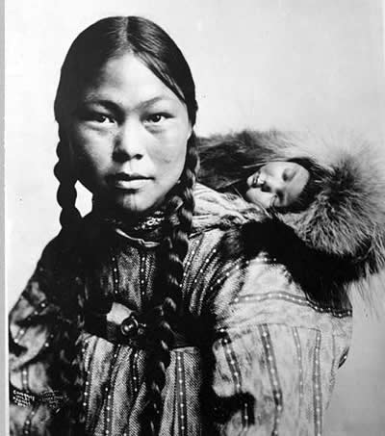
Even though the current version of the Act does not mention Inuit, the government acknowledges some responsibility to them. Therefore, a number of programs and policies for Inuit are administered through Indian and Northern Affairs Canada.
To some extent, Inuit’s relationship with the Act was determined by geography, since their traditional lands were centered in the High Arctic. When the Indian Act first passed in 1876, there was no rush of settlers clamouring for Inuit lands. Inuit at this time had little contact with other Canadians besides those working the fur trade, such as employees of the Hudson’s Bay Company. For all these reasons, the federal government felt no need to sign treaties with Inuit, nor to define their legal status in Canada through a law such as the Indian Act.
In the early part of the 20th century, the Royal Canadian Mounted Police (RCMP) established posts in the Arctic, and missionaries started working among Inuit. Some confusion developed over Inuit status – should Mounties deal with them as First Nations people or as ordinary Canadians? For example, should it be illegal for Inuit to buy liquor as it was for Fist Nations people under the Indian Act?
To deal with such questions, the government amended the Act in 1924 to make the Superintendent General of Indian Affairs responsible for “Eskimo affairs.” At this time, the government took little other action in regard to Inuit, partly because many officials suspected that the policies set forth in the Indian Act had been expensive failures. As O.S. Finnie in the department of the Interior delicately put it, Inuit, “will not be developed to the best advantage by the adoption of the methods used in dealing with Indians.”
For the most part, the government let the missionaries and trading companies look after matters of education, health, and social assistance among Inuit. In the late 1920s, however, the fur trade collapsed and game animals such as caribou began to vanish from large parts of their ranges. These two long-term trends made it clear that the government had to do something to avoid widespread starvation among Inuit.
This prompted one of the first large-scale social assistance programs for the people of the Arctic. In 1929, the federal government bought a herd of 3000 caribou from an Alaskan company that had imported them earlier from northern Europe. It took five years to transport the animals 3200 kilometres from northern Alaska to Kittigazuit, in the eastern Mackenzie Delta. The epic journey above the Arctic Circle caught the attention of the Canadian public as newspapers chronicled the herd’s progress as the herders dealt with blizzards, stampedes, wolf packs and unexplored mountain ranges.
The success of this one program could not make up for the general decline of game animals across the Arctic. In the 1930s, the Great Depression made matters worse for Inuit. When the Quebec government asked to be repaid for relief money spent on Inuit living in Quebec, Canada refused. Federal officials claimed that Inuit in Quebec were a provincial responsibility.
The Supreme Court disagreed. In a 1939 ruling known as “Re Eskimos,” the court found several precedents (earlier, relevant cases) in Canadian law for identifying Inuit as “Indians.” This meant that Inuit, no matter where they lived, were a federal responsibility, since the BNA Act gave jurisdiction over “Indians and the lands reserved for the Indians” to the federal government.
Parliament more or less ignored the Court’s ruling. Though Inuit were still included in the Indian Act, all programs and policies for them were administered separately from those for First Nations. In 1951, the government revised the Act and removed any mention of Inuit from it. In general, the government developed a policy of treating Inuit as ordinary Canadians who required special attention.
By the 1950s, however, the Cold War had made clear the strategic importance of the Arctic lands where Inuit lived. In response, the government built a network of weather and radar stations that stretched from Alaska to Baffin Island. At the same time, it stepped up attempts to encourage Inuit to move to permanent settlements, where it would be easier to provide health and education services.
None of these settlements were at sites that Inuit chose themselves. Many of them turned out to be unsuitable, either because hunting and fishing were poor or because ice formations made travel impossible. Certain communities were forced to relocate to distant regions for political reasons, especially when the government wanted to establish a claim to a disputed area.
In response to such treatment, Inuit leaders developed their own political organizations to better represent their interests to the federal government. The Inuit Tapirisat of Canada was formed in 1971, and later changed its name to Inuit Tapirisat Kanatami (ITK), which means “Inuit are united in Canada.” The main goals of this organization were to preserve Inuit language and culture and to achieve the right of self-government. The ITK’s work over many years contributed to the recognition of Inuit as one of the three Aboriginal peoples in the Constitution Act and to the creation of the new territory of Nunavut in 1999.
Another result of the ITK’s lobbying efforts was the formation, in 2005, of the Inuit Relations Secretariat within the Department of Indian and Northern Affairs Canada. This body serves as the government contact point for collaboration with various Inuit organizations. It also provides information and advice on matters of concern to Inuit.

The Cold War was a fifty yearlong conflict between the United States and the Soviet Union. Both sides had nuclear missiles pointed at each other and the shortest route between the two powers was over the Arctic. This made early detection stations in the Arctic very important.

